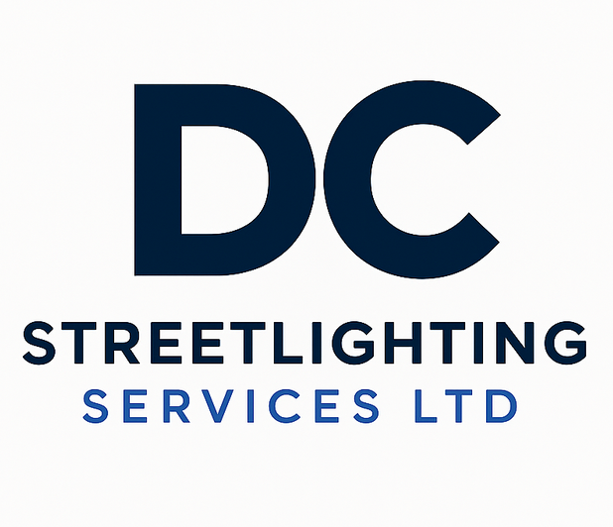
STREET LIGHTING ADOPTION
& DEFECT CLEARANCE
Capability Statement
Inspection • Defect Schedule • Remedial Works • Testing • Handover Support
Helping developers, adoption companies and principal contractors progress street-lighting assets from defect identification through to compliant handover and adoption.

A practical route from defects to adoption
DC Streetlighting Services Ltd provides a specialist Street Lighting Adoption & Defect Clearance service for developers, adoption specialists, principal contractors and infrastructure organisations. Our service is designed to help identify, manage and close out street-lighting defects that can delay final inspections, highway adoption and associated project close-out.
Rather than providing labour in isolation, we support the complete defect-clearance process: site inspection, defect scheduling, quotation, remedial works, electrical testing, asset and CMS information, photographic evidence, close-out documentation and liaison support through final inspection.

The challenge we help solve
- Street-lighting defects identified late in the adoption process.
- Incomplete or inconsistent asset, testing, CMS or as-built information.
- Multiple subcontractors and unclear responsibility for closing defects.
- Repeat inspections caused by incomplete remedial works or missing evidence.
- Programme delay affecting adoption, completion milestones and bond release.

Our capability
Service Stage | What DC Streetlighting Provides
Initial Adoption Health Check | Review available defect lists, drawings, asset information and site status to establish the likely scope and priorities.
Site Inspection & Defect Verification | Inspect street-lighting assets, verify reported defects, identify additional visible issues and create a clear action schedule.
Defect Schedule & Commercial Proposal | Provide an organised defect schedule and quotation so responsibilities, priorities and costs are transparent.
Remedial & Completion Works | Undertake agreed street-lighting remedial works using competent personnel, appropriate RAMS and safe systems of work.
Electrical Testing & Certification | Complete applicable inspection, testing and supporting electrical documentation for the assets within our scope.
CMS / Asset Information Support | Assist with collection and close-out of relevant asset data, labels, inventories and CMS-related information where required.
Evidence & Handover Documentation | Compile photographs, test information, asset schedules and close-out records into a structured handover pack.
Final Inspection Support | Support defect close-out, responses to inspection comments and further remedial actions required to progress adoption.

A structured defect-clearance process
1. Review Receive the available defect list, drawings, specifications, test records, asset schedules and adoption comments.
2. Inspect Attend site, verify asset condition and confirm the physical scope of outstanding street-lighting works.
3. Schedule Produce or refine the defect schedule, prioritising safety-critical, compliance and adoption-related items.
4. Quote Provide a clear commercial proposal for the agreed remedial and close-out works.
5. Rectify Deliver the works under suitable planning, RAMS, traffic/pedestrian management and competent supervision.
6. Test & Record Complete applicable electrical testing, photographs, asset information and supporting records.
7. Close Out Issue a structured completion / handover pack and support responses to final inspection comments.

Developer Street Lighting Handover Pack
Where required, DC Streetlighting can assemble a project-specific handover pack to provide a clear audit trail of the street-lighting works completed within our scope. The final content can be aligned to the adopting authority, project specification and information made available to us.
- Current defect schedule and close-out status
- Electrical inspection / test documentation applicable to completed works
- Asset schedules and identification information
- Photographic completion evidence
- CMS-related information supplied or collected within scope
- As-built information supplied for inclusion in the handover
- Remedial works / completion register
- Outstanding actions and exclusions, where applicable

Adoption Health Check
A straightforward first step for stalled or approaching-adoption sites. Send us the available street-lighting defect list, drawings and supporting information. We can undertake an initial review to help identify the likely workstreams, information gaps and practical next steps before a full remedial package is agreed.

Why appoint DC Streetlighting Services Ltd?
Specialist street-lighting focus: A service built around highways electrical and street-lighting assets rather than general construction defect management.
Single-point defect clearance: A coordinated route from inspection and quotation through remedial works, testing and close-out evidence.
Safety-led delivery: Works planned around competent personnel, RAMS, public protection, traffic/pedestrian interfaces and appropriate work-at-height controls.
Procurement-friendly documentation: Clear scopes, defect schedules, records and close-out information that support client governance and audit requirements.
Flexible project support: Suitable for individual problem sites, pre-adoption reviews or multi-site defect-clearance programmes across the United Kingdom.

Typical clients and project situations
- Residential and mixed-use developers approaching Section 38 / highway adoption milestones.
- Adoption management companies requiring a specialist street-lighting delivery partner.
- Principal contractors closing infrastructure packages before handover.
- Sites with recurring street-lighting defects following inspection.
- Projects where incomplete test, asset, CMS or photographic records are preventing close-out.
- Multi-phase developments requiring an organised programme of inspection and defect clearance.

Scope tailored to the adopting authority
Adoption requirements vary between highway authorities, project specifications and asset owners. DC Streetlighting therefore agrees the precise scope, evidence requirements, testing, asset information and acceptance criteria on a project-by-project basis. Our role is to provide a controlled, documented and practical route to close the street-lighting items within our agreed responsibility.

Engagement model
1. Send Information | 2. Agree Scope | 3. Clear & Close Out
Defect list, drawings, inspection comments, asset information and target adoption dates. | We review the information, inspect where required and provide a defined proposal. | We complete the agreed works, record evidence and support the close-out process.

Start with an Adoption Health Check
Have a site with outstanding street-lighting defects?
Provide the available defect schedule, drawings and inspection information to DC Streetlighting Services Ltd for an initial review. We can then help define the route from outstanding defects to a structured, evidenced close-out package.

